IRI Hackathon
Team 2
Ruiz, Edward
2026
Table of Contents
Document Overview 3
Business Objective 3
Business, Resource, and Technology Assumptions, Constraints, Risks, & Dependencies 3
Use-Case – Customer Policy 3
Industry Current State 4
Industry Future State 5
In-Scope Functional and Non-Functional Requirements 5
1.0 Retrieve Policy Information 5
2.0 Renewal Detection 6
3.0 Notification to Advisor Tool 7
4.0 Advisor is Alerted/Advisor Views the Alert 7
5.0 Option Presentation 9
6.0 Advisor Review & Client Discussion 11
7.0 Transaction Selection 13
8.0 Application & Documentation Generation 14
9.0 Submission & Tracking 15
Appendix A – Sample Screens 18
Appendix B – Process Map 20
Appendix C – Sample UI JSON 20
Appendix D – Sample Prompt 22

Version History
Version | Details of Change | Prepared By | Date
0.01 | Initial Draft | Edward Ruiz | 1/30/2025
0.02 | Created two new sections for napkin sketches  - Industry current and future state  Additions to Section 5.0  - Added dynamic LLM prompt modification capabilities to ensure AI insights update when guaranteed income or product inputs change.  - Introduced advisor-controlled product preference slider for weighted comparison based on client preferences.  - Added a magic quadrant visualization to compare eligible products across key axes such as guarantees, liquidity, or advisor-selected attributes.  - Added configurable comparison criteria selection to tailor product comparison views and AI explanations.  - Enhanced AI reasoning outputs to reflect real-time advisor inputs, criteria selections, and preference weightings.  - Introduced guaranteed-income sensitivity modeling and integrated the results into AI-generated suitability considerations.  - Enabled configurable AI insight panels for product differentiation (e.g., liquidity, guarantees, risk).  - Added UI state persistence for advisor inputs (slider settings, criteria selections, quadrant choices).  Added Appendix B, C, D  - Added process Map for visual  - Included a Sample UI JSON that can be used as an input to the LLM prompt  - Included a sample prompt which will use the JSON in Appendix C as an input | Edward Ruiz | 2/9/2026
0.03 | Additions to section 5 and 6  - Added goal-aligned visualization logic to ensure graphs reflect customer and advisor inputs, including mandatory retirement income representation when applicable.  - Introduced single-goal focus with ranked multi-goal scoring to balance clarity and flexibility.  - Added Gantt-style timeline visualization for comparing product dimensions across multiple products.  - Enhanced graph interactions with multi-variable hover comparisons, including funding source, ownership, and plan type attributes.  - Introduced a two-part product selection flow, including conditional living-benefit selection for income-based goals.  - Added advisor eligibility indicators (green/yellow/red) tied to licensing, training, and appointment status.  - Introduced “Coming Soon” actions with guided remediation paths for ineligible products.  - Added line-graph visualizations for rate changes and performance-over-time modeling aligned to selected goals and assumptions. | Edward Ruiz | 2/19/2026

Document Overview
Design a streamlined, advisor-friendly front-end experience that consolidates key business processes, surfaces actionable insights, and supports efficient new business and in-force activities — all powered by IRI standardization and other related new(er) capabilities.

Business Objective
The agent experience will guide advisors through the essential data points and workflows required to support customer conversations, product recommendations, and transactional activities.

Business, Resource, and Technology Assumptions, Constraints, Risks, & Dependencies
- Business Assumptions
  - Carriers are providing accurate, timely product and renewal data so we can surface meaningful alerts and comparisons.
  - Advisors already have the proper client authorization and are expected to use the tool as part of their normal workflow.
  - Suitability and compliance rules we receive are current, consistent, and can be applied across products.
  - IRI standards and other data structures will be reliable enough to support cross-carrier consistency.
  - Advisors remain responsible for the actual client conversation and final recommendation—the tool simply streamlines and supports that process.
- Technology Assumptions
  - We have (or will have) the integrations needed with carrier admin systems via DTCC or otherwise, product data feeds, suitability engines, and order-entry platforms.
  - Market data, product attributes, and policy information refresh at a frequency that allows the AI to operate accurately.
  - The AI has access to the structured data required to identify renewals, compare products, and help support suitability and NIGO/IGO checks.
  - Advisors authenticate through secure, role-based access, and all actions can be logged for audit.
  - The system can pre-fill forms and generate the documentation needed, assuming required data points exist and meet carrier standards.
  - The front-end experience will depend on stable APIs and consistent payloads to render alerts, product info, and policy details in real time.
  - The platform will scale to support advisor usage without performance issues.

Use-Case – Customer Policy
Business Area
Annuity Administration / Advisor Sales Enablement
Primary Actor
Financial Advisor
Supporting Actors
- Carrier Administration System
- AI-Driven Advisor Tool (Sales & Decision Support Platform)
- Product Data Providers (Rates, Product Features, Market Data)
- Compliance & Suitability Engine
Stakeholders
- Client / Contract Owner – Receives timely and suitable annuity recommendations
- Financial Advisor – Identifies renewal risk and alternative solutions efficiently
- Insurance Carrier(s) – Improves retention and appropriate replacement outcomes
- Compliance & Risk Management – Ensures suitability and documentation
- Operations / New Business – Receives complete and accurate applications
Business Need / Problem Statement
Fixed rate annuities approaching renewal—especially those renewing at a minimum guaranteed interest rate—present a high risk of poor client outcomes and lost opportunities. Advisors often lack timely visibility into renewal events, competitive market alternatives, and required documentation, resulting in missed client engagement and suboptimal decisions.

Industry Current State

Industry Future State

In-Scope Functional and Non-Functional Requirements

Retrieve Policy Information
ID | Functional Requirements
1.01 | The system shall retrieve all in-force policies associated with the advisor based on the advisor’s entitlements and client relationships.
1.02 | The system shall pull key policy data from the carrier administration system, including:  - Contract number  - Client/owner information  - Policy status  - Policy type and product family  - Cash values and surrender values  - Premium and transaction history  - Renewal date and renewal rate (if applicable)  - Credited rate  - Riders, features, and service flags
1.03 | The system shall identify and tag eligibility indicators, including:  - Renewal eligibility  - Upgrade or replacement suitability  - Additional contribution eligibility  - Carrier-specific constraints or rules
1.04 | The system shall validate that all required policy fields are present, current, and usable.
1.05 | The system shall flag policies with missing or inconsistent data as “data exceptions.”
1.06 | The system shall prevent downstream workflows that depend on missing fields from executing until the data is resolved.
1.07 | The system shall generate a standardized Policy Summary object that includes:  - Core contract metadata  - Key policy values  - Dates and renewal information  - Eligibility and service flags  - Suitability-related information
1.08 | The system shall package the Policy Summary for use in:  - Renewal detection  - Advisor notification logic  - Product comparison workflows  - AI analysis, including suitability and replacement logic

Renewal Detection
ID | Functional Requirements
2.01 | The system shall identify policies that fall within the defined renewal window (e.g., 30 days prior to the renewal date).
2.02 | The system shall retrieve and store the renewal rate associated with the policy, including the guaranteed minimum interest rate.
2.03 | The system shall detect when a policy is scheduled to renew at its guaranteed minimum rate and shall flag the policy as “Minimum Rate Renewal.”
2.04 | The system shall verify that the policy is eligible for a renewal review, including checking:  - Active policy status  - Product type (fixed annuity)  - No pending replacements, surrenders, or transactions  - Advisor authorization
2.05 | The system shall create a Renewal Event record for each eligible policy that includes:  - Contract metadata  - Renewal date  - Current rate and renewal rate  - Minimum rate flag (if applicable)  - Any relevant policy or suitability indicators
2.06 | The system shall flag any policies missing required renewal fields as “Renewal Data Exceptions.”
2.07 | The system shall suppress renewal detection workflows for those policies until data issues are resolved.
2.08 | The system shall pass the Renewal Event to the notification engine for subsequent advisor alerting logic.

Notification to Advisor Tool
ID | Functional Requirements
3.01 | The system shall transmit each Renewal Event to the advisor-facing tool through a standardized integration interface (API or message queue).
3.02 | The system shall format Renewal Event data using IRI-aligned or carrier-approved data structures to ensure consistency across carriers.
3.03 | The system shall confirm that the advisor associated with the policy has authorization to view the client and the Renewal Event before surfacing any notification.
3.04 | The system shall create an Advisor Alert record that includes:  - Policy and contract identifiers  - Renewal date  - Current rate and renewal rate  - Minimum rate flag (if applicable)  - Suitability or product-specific indicators
3.05 | The system shall queue the Advisor Alert to be displayed on the advisor’s next login or session refresh.
3.06 | The system shall assign a priority level to the alert (e.g., “High Impact Renewal”) when specific risk factors are present, such as renewal at the guaranteed minimum rate.
3.07 | The system shall log the creation, processing, and transmission of each Advisor Alert for auditing and compliance purposes.
3.08 | The system shall flag and log any transmission failures and shall retry based on system-defined retry rules.

Advisor is Alerted/Advisor Views the Alert
ID | Functional Requirements
4.01 | The system shall display an alert to the advisor at login or session refresh when a Renewal Event exists and the advisor is authorized to view it.
4.02 | The system shall present key alert details at-a-glance, including policy identifier, client/owner name, renewal date, current rate, renewal rate, and a minimum-rate flag if applicable.
4.03 | The system shall show the alert priority (e.g., High, Medium, Low) and visually distinguish higher priority alerts from standard alerts.
4.04 | The system shall allow the advisor to open the alert to view a detailed panel with full policy context and next-step actions.
4.05 | The system shall provide actions within the alert detail to review options, dismiss, snooze, or assign/follow-up as a task.
4.06 | The system shall require a reason code and optional comment when dismissing an alert, for tracking purposes.
4.07 | The system shall allow the advisor to snooze an alert to a selectable future date/time within configurable business rules (e.g., 3, 7, 14 days).
4.08 | The system shall record alert interactions (viewed, opened, snoozed, dismissed, assigned) with timestamps and advisor identity for audit.
4.09 | The system shall throttle duplicate alerts for the same policy and renewal event to avoid alert fatigue, while still surfacing material changes (e.g., updated renewal rate).
4.10 | The system shall update the alert state in real time across advisor sessions to prevent conflicting actions (e.g., a dismissed alert should not reappear unless resurrected by updated data).
4.11 | The system shall surface eligibility indicators and data exceptions inline on the alert detail when they impact downstream workflows (e.g., missing renewal rate blocks comparisons).
4.12 | The system shall make alerts searchable and filterable by client, policy, carrier, renewal date window, and priority.
4.13 | The system shall paginate or virtualize alert lists to maintain performance at scale without degrading load time.
4.14 | The system shall degrade gracefully when some alert data is unavailable by showing a clear “data exception” banner with the impacted fields.
4.15 | The system shall localize alert labels, dates, and currency formats based on the advisor’s locale settings.
4.16 | The system shall provide a direct link from the alert to the policy’s full summary page for deeper review.
4.17 | The system shall persist alert state in a way that survives browser/device changes for the same advisor identity.
4.18 | The system shall support configuration of the default alert sorting (e.g., priority desc, renewal date asc) at the firm level.

Option Presentation
ID | Functional Requirements
5.01 | The system shall display the existing policy’s renewal details when the advisor opens the alert, including renewal date, renewal rate, credited rate, and guaranteed minimum rate.
5.02 | The system shall present a clear summary of the policy’s features, benefits, riders, and any limitations relevant to the renewal decision.
5.03 | The system shall retrieve and display eligible alternative products based on client profile, advisor licensing, carrier availability, and suitability rules.
5.04 | The system shall filter out products that do not meet basic suitability or best-interest criteria before presenting them to the advisor.
5.05 | The system shall provide a side-by-side comparison between the existing policy and eligible alternatives, including rates, surrender terms, features, riders, bonuses, and other key attributes.
5.06 | The system shall highlight material differences between the existing annuity and each alternative (e.g., higher rate, loss of benefits, liquidity changes).
5.07 | The system shall clearly indicate whether each option is renewal, replacement, or another transaction type and surface any associated rules or restrictions.
5.08 | The system shall show any required disclosures, compliance notes, or carrier-specific instructions tied to renewal or replacement decisions.
5.09 | The system shall surface AI-generated insights or recommendations, such as suitability considerations, market competitiveness, or risks associated with renewing at the minimum rate.
5.10 | The system shall allow the advisor to drill into any alternative product for deeper details, including prospectus information, rider descriptions, and state-specific variations.  Note: feature would filter out unsuitable products
5.11 | The system shall flag any missing data that reduces the accuracy of product comparison and display a clear notice to the advisor.
5.12 | The system shall support exporting or printing a client-friendly version of the comparison to support discussions and documentation.
5.13 | The system shall log which product comparisons were viewed by the advisor and any associated interactions for tracking.
5.14 | The system shall ensure that all displayed product data is current according to the most recent market/rate refresh.
5.15 | The system shall allow the advisor to indicate which options were reviewed with the client to support downstream documentation.
5.16 | The system shall display the existing policy’s renewal details when the advisor opens the alert, including renewal date, renewal rate, credited rate, and guaranteed minimum rate.
5.17 | The system shall present a clear summary of the policy’s features, benefits, riders, and any limitations relevant to the renewal decision.
5.18 | The system shall retrieve and display eligible alternative products based on client profile, advisor licensing, carrier availability, and suitability rules.
5.19 | The system shall dynamically modify AI/LLM prompt parameters when guaranteed income, income base, or other relevant values change, ensuring that AI-generated insights reflect real-time product and customer data.
5.20 | The system shall provide a slider control that allows the advisor to indicate client preference weighting (e.g., guarantee vs. growth, liquidity vs. rate), and shall update product scoring or ranking dynamically based on these selections.
5.21 | The system shall generate a “magic quadrant” or 2×2 matrix visualization for eligible products, allowing advisors to compare options across two key dimensions (e.g., guarantees vs. liquidity, rate vs. risk, or advisor-selected criteria).
5.22 | The system shall allow advisors to select comparison criteria (e.g., surrender periods, guaranteed income, renewal rate risk, liquidity features, riders) and dynamically update the comparison table, charts, and insights accordingly.
5.23 | The system shall adjust the LLM prompt based on advisor-selected criteria or preference weighting and generate updated explanations, suitability considerations, and rationale tailored to the customer’s priori5.26ties.
5.24 | The system shall recalculate product competitiveness when guaranteed income or payout assumptions change, and the LLM shall incorporate these values into tailored recommendations and narratives.
5.25 | The system shall allow configurable AI-generated insight tiles (e.g., “Higher Guaranteed Income,” “Better Liquidity,” “Shorter Charge Schedule”), each driven by logic and dynamically updated prompts.
5.26 | The system shall preserve advisor inputs (slider settings, selected criteria, quadrant views) across session refresh and navigation, enabling continuous iterative comparison.
5.27 | The system shall align all comparison graphs and visualizations to the customer’s selected primary goal (e.g., retirement income, accumulation, liquidity preservation).
5.28 | When a retirement income goal is selected, the system shall ensure retirement income is explicitly represented on all applicable graphs and charts.
5.29 | The system shall allow the advisor to designate a single primary goal for visualization focus, while ranking products across additional selected goals as secondary indicators.
5.30 | When multiple goals are selected, the system shall calculate and display a ranked score for each product based on relative alignment to each goal, with the primary goal weighted highest.
5.31 | The system shall display product dimensions (e.g., surrender period, income start date, rate reset windows, benefit duration) on a unified Gantt-style chart to illustrate timelines and tradeoffs.
5.32 | The system shall allow multiple products to be displayed concurrently on the Gantt chart to enable side-by-side temporal comparison.
5.33 | The system shall support hover-based interactions on graphs and charts that surface detailed comparisons across multiple variables.
5.34 | The hover details shall include funding source attributes when available, including but not limited to:  - Inherited assets  - 401(k) / qualified plan assets  - IRA / Roth IRA  - Non-qualified assets  - Other ownership types
5.35 | The system shall display plan type and ownership attributes in hover details when they materially impact suitability, taxation, or product eligibility.
5.36 | The system shall allow the advisor or customer to select the product types they wish to evaluate (e.g., fixed, fixed indexed, RILA, variable) as the first step in the comparison flow.
5.37 | If an income-related goal is selected, the system shall prompt the advisor or customer to indicate whether a living benefit (e.g., GLWB, GMIB) is desired.
5.38 | The system shall use the living benefit selection to inform product highlighting and ranking logic without removing products from view.
5.39 | The system shall display an eligibility indicator for each product based on the advisor’s profile, reflecting selling, training, and licensing status.
5.40 | The system shall represent eligibility using standardized visual indicators:  - Green: Advisor is licensed, trained, and eligible to sell  - Yellow: Advisor is partially eligible (e.g., training or appointment pending)  - Red: Advisor is not currently eligible to sell
5.41 | The system shall provide hover-over explanations for yellow and red indicators, detailing the specific eligibility gaps.
5.42 | Eligibility indicators shall be dynamically calculated using the advisor’s profile, including licenses, appointments, training completion, and firm permissions.
5.43 | When a product is not currently sellable by the advisor, the system shall display a “Coming Soon” or equivalent action.
5.44 | Selecting the “Coming Soon” action shall direct the advisor to guidance on how to resolve eligibility gaps, such as licensing steps, training requirements, or appointment processes.
5.45 | The system shall display a line graph illustrating historical and/or projected rate changes for products when available.
5.46 | The system shall support visualizing how a product could perform over time based on rates, crediting methods, or income assumptions, using standardized modeling logic.
5.47 | Performance-over-time graphs shall remain consistent with the selected goal, funding source, and living benefit assumptions used elsewhere in the comparison.

Advisor Review & Client Discussion
ID | Functional Requirements
6.01 | The system shall allow the advisor to mark which options (renewal, replacement alternatives) were reviewed with the client and capture the date of discussion.
6.02 | The system shall provide a client-friendly view of the comparison that the advisor can present during the meeting, including clear explanations of trade-offs, benefits, and risks.
6.03 | The system shall enable capture of client objectives, risk tolerance, time horizon, liquidity needs, tax considerations, and other suitability factors required for best-interest documentation.
6.04 | The system shall prefill suitability inputs from existing client data where available and clearly indicate which fields were prefilling vs. entered during the discussion.
6.05 | The system shall allow the advisor to record the client’s preferences and rationale (e.g., prioritize guaranteed rate vs. upside potential) as structured fields and free-form notes.
6.06 | The system shall surface required disclosures applicable to each option and require advisor acknowledgment that disclosures were reviewed with the client.
6.06 | The system shall dynamically update suitability assessment results as advisor inputs are added or changed during the discussion.
6.07 | The system shall flag any suitability gaps (e.g., missing financial profile data, conflicting objectives) and prevent moving forward until resolved or a compliant exception process is followed.
6.08 | The system shall capture explicit client consent/acknowledgment that options and trade-offs were discussed, using e-signature or logged acknowledgement where supported.
6.09 | The system shall record evidence of what was shown to the client (e.g., versioned comparison PDF or snapshot) and store it with the case record for reference.
6.10 | The system shall track who attended the discussion (advisor, client, joint owner, POA) and the meeting channel (in-person, video, phone) for tracking.
6.11 | The system shall provide prompts for questions the advisor should cover (e.g., surrender charges, MVA, rider impacts, replacement implications) and require confirmation that each was addressed.
6.12 | The system shall support saving an in-progress discussion and resuming later without data loss across devices and sessions.
6.13 | The system shall maintain an immutable activity log of all entries, edits, acknowledgments, and generated artifacts tied to the discussion.
6.14 | The system shall restrict editing of captured client attestations or signed acknowledgments after submission and shall support addenda with full audit trail.
6.15 | The system shall provide a single action to proceed to transaction selection once suitability and disclosure requirements are satisfied.
6.16 | The system shall store the discussion record with cross-reference to the client, policy, and any proposed replacement or renewal transaction IDs.
6.17 | The system shall expose APIs to retrieve the discussion record and attached artifacts for downstream compliance review and supervision.
6.18 | The system shall capture customer and advisor inputs (goals, funding source, product preferences) as structured fields and use them to dynamically update graphs and rankings.

Transaction Selection
ID | Functional Requirements
7.01 | The system shall allow the advisor to select the client’s chosen transaction path: renew the existing policy or replace it with an alternative product.
7.02 | The system shall validate that all required suitability and disclosure steps from the previous phase have been completed before allowing the advisor to proceed.
7.03 | The system shall enforce carrier-specific or regulatory restrictions that may limit which transaction types are available.
7.04 | The system shall display any carrier rules that impact transaction eligibility at the moment the advisor makes the selection (e.g., replacement blackout periods, required holding periods).
7.05 | The system shall confirm advisor licensing and appointment status for the selected product or transaction type and prevent ineligible selections.
7.06 | The system shall provide a confirmation step summarizing the selected option, including key policy attributes, financial implications, and suitability indicators.
7.07 | The system shall allow the advisor to revise or go back to the comparison step if the client changes their decision.
7.08 | The system shall capture and store the advisor’s rationale for the selected transaction type and any relevant client statements required for documentation.
7.09 | The system shall trigger the appropriate workflow based on the advisor’s selection (renewal workflow, replacement workflow, or variant transaction process).
7.10 | The system shall record the transaction selection with timestamp, advisor identity, and policy or product IDs for audit tracking.
7.11 | The system shall display any additional steps or requirements that are specific to the chosen transaction (e.g., replacement-only disclosures).
7.12 | The system shall block submission if required fields or acknowledgments are missing and provide a clear indication of what must be completed.
7.13 | The system shall generate a unique transaction ID to track the selected renewal or replacement action through downstream processing.
7.14 | The system shall support saving transaction selection in draft state and resuming it later without losing previous inputs.
7.15 | The system shall restrict changes to the transaction selection after final submission unless an authorized correction process is initiated.
7.16 | The system shall notify downstream systems (e.g., order-entry, suitability engine) of the selected transaction type in a standardized data payload leveraging IRI standards, if available or resort to using ACORD.
7.17 | The system shall support error messaging if downstream workflow initiation fails and provide a retry or correction mechanism.
7.18 | The system shall provide end-of-step guidance directing the advisor to the next required stage—application, documentation, or additional suitability steps.
7.19 | The system shall confirm successful initiation of the next workflow and present a clear on-screen status indicator.

Application & Documentation Generation
ID | Functional Requirements
8.01 | The system shall generate all required forms, disclosures, and documentation based on the selected transaction type (renewal or replacement).
8.02 | The system shall prefill application and disclosure fields using existing client, product, and advisor data where available.
8.03 | The system shall clearly indicate any fields that were not prefilled and require advisor input.
8.04 | The system shall dynamically assemble the correct packet of carrier-specific forms depending on state, product, tax-qualification type, and carrier rules.
8.05 | The system shall retrieve the latest version of all forms to ensure regulatory and carrier compliance.
8.06 | The system shall generate suitability documentation based on the advisor’s inputs, client discussion data, and completed suitability responses.
8.07 | The system shall automatically attach required replacement disclosures and comparison summaries when the advisor selects a replacement transaction.
8.09 | The system shall validate completeness of all required data fields before allowing application submission.
8.10 | The system shall flag missing, inconsistent, or contradictory data in the application and prevent submission until issues are resolved.
8.11 | The system shall apply NIGO/IGO checks against carrier (leverage the PPfA) and regulatory rules (optional for hackathon) to identify potential issues prior to submission.
8.12 | The system shall provide clear error messages and instructions for resolving NIGO items.
8.13 | The system shall support attaching supplemental documents (e.g., driver’s license, trust documentation, financial statements) when required.
8.14 | The system shall support e-signature workflows for forms that allow digital signatures.
8.15 | The system shall provide a client-friendly packet preview that the advisor can review with the client before submission.
8.16 | The system shall log all generated documentation and versions for audit review.
8.17 | The system shall support printing, exporting, or securely sharing application packets when needed for client interaction.
8.18 | The system shall store all completed forms and documents in the case file for downstream processing.
8.19 | The system shall update the transaction record once documentation is completed and validated.
8.20 | The system shall enable the advisor to proceed to submission only after all required documentation steps are successfully completed.

Submission & Tracking
ID | Functional Requirements
9.01 | The system shall submit the completed application packet, disclosures, and supporting documents to the appropriate carrier or order-entry platform using standardized electronic integration.
9.02 | The system shall transmit the submission payload in the carrier-required format, including product details, client information, advisor information, and all attached documentation.
9.03 | The system shall validate that all required forms and fields are present before submission and prevent transmission if critical components are missing.
9.04 | The system shall display a confirmation message once the submission is successfully transmitted and include the carrier or platform submission ID when available.
9.05 | The system shall create a submission record containing timestamps, transaction ID, payload metadata, and the receiving carrier or platform.
9.06 | The system shall track submission status updates (e.g., Received, In Review, NIGO, Approved, Issued) and display them in real time to the advisor.
9.07 | The system shall retrieve and surface NIGO (Not In Good Order) messages returned by the carrier, including missing fields or corrective actions needed.
9.08 | The system shall allow the advisor to correct NIGO items directly within the platform when supported, or provide instructions when manual correction is required.
9.09 | The system shall re-validate corrected submissions and allow resubmission once issues are resolved.
9.10 | The system shall maintain an activity log of all submission attempts, corrections, and status changes for audit purposes.
9.11 | The system shall notify the advisor of key status changes through in-app alerts and optional email or push notifications.
9.12 | The system shall store all submission documents and artifacts in a centralized case file accessible for compliance review, supervision, and carrier inquiries.
9.13 | The system shall restrict editing of submissions after they reach a final carrier status (e.g., Approved, Issued, Declined) unless an authorized escalation process is triggered.
9.14 | The system shall support linking the submission record to downstream systems for compensation, policy issuance, and reporting.
9.15 | The system shall allow the advisor to view submission history across all clients and carriers, sorted by date, product, carrier, or status.
9.16 | The system shall provide APIs to expose submission status and historical submission data leveraging IRI standard application status.
9.17 | The system shall ensure error handling is applied to failed transmissions and provide advisors with next steps or retry options.
9.18 | The system shall record any system or integration failures with full diagnostic logging to support technical troubleshooting.
9.19 | The system shall enforce data encryption and secure transmission protocols for all outgoing submission data.
9.20 | The system shall finalize the workflow when the carrier returns a completed status, marking the transaction as fully closed and ready for archival or supervision review.
9.21 | The system shall submit the completed application packet, disclosures, and supporting documents to the appropriate carrier or order-entry platform using standardized electronic integration.
9.21 | The system shall transmit the submission payload in the carrier-required format, including product details, client information, advisor information, and all attached documentation.
9.21 | The system shall validate that all required forms and fields are present before submission and prevent transmission if critical components are missing.
9.22 | The system shall display a confirmation message once the submission is successfully transmitted and include the carrier or platform submission ID when available.
9.23 | The system shall create a submission record containing timestamps, transaction ID, payload metadata, and the receiving carrier or platform.

Appendix A – Sample Screens
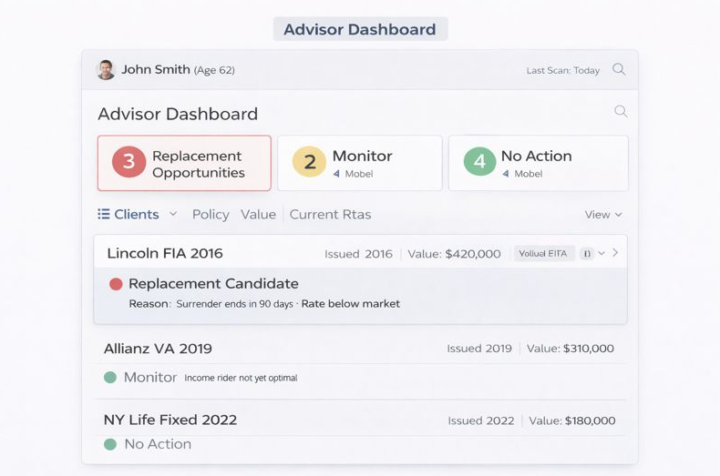
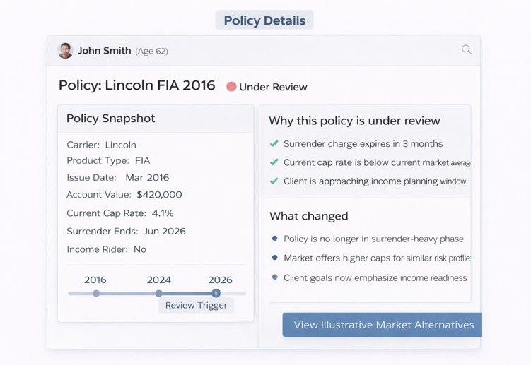
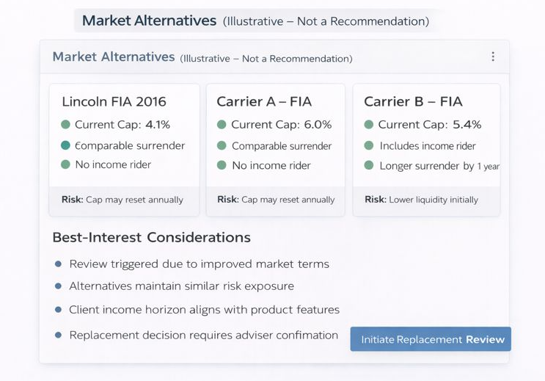
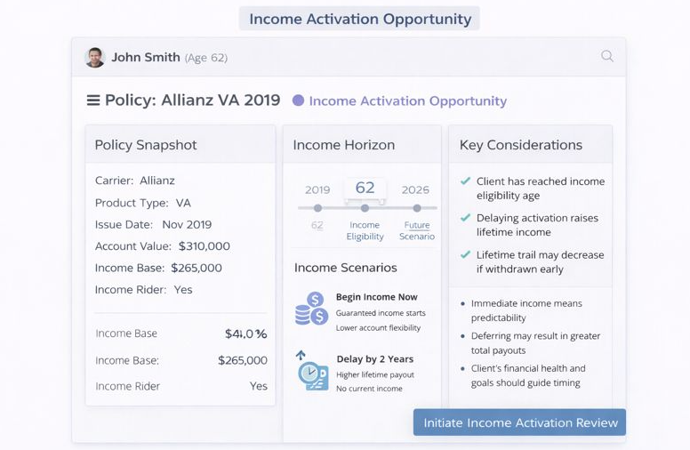
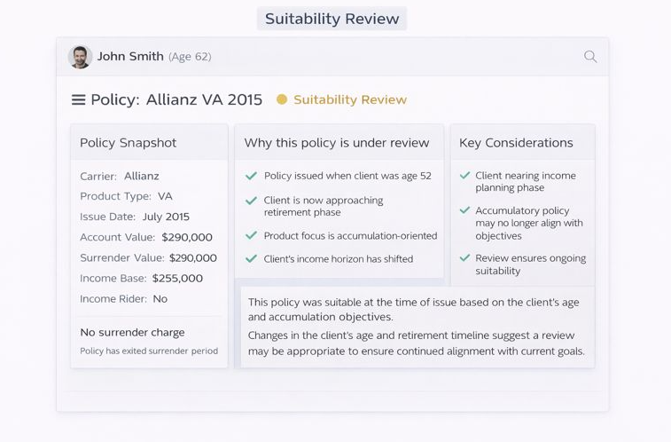

Appendix B – Process Map

Appendix C – Sample UI JSON
{
"context": {
"advisorId": "A12345",
"client": {
"id": "C77890",
"age": 64,
"state": "NC",
"taxQualification": "Non-Qualified",
"riskTolerance": "Moderate",
"objectives": ["Income stability", "Liquidity"]
},
"policy": {
"contractNumber": "FA-000111",
"productFamily": "Fixed Annuity",
"status": "In-Force",
"creditingRate": 0.025,
"renewalDate": "2026-03-15",
"renewalRate": 0.020,
"guaranteedMinimumRate": 0.015,
"guaranteedIncomeAnnual": 18500
}
},
"eligibleProducts": [
{
"productId": "P-AX1",
"carrier": "Carrier A",
"type": "Fixed",
"baseRate": 0.032,
"surrenderScheduleYears": 5,
"liquidityFeatures": ["10% free withdrawal"],
"riders": ["GMIB"],
"guaranteedIncomeAnnual": 19250,
"feesBps": 0
},
{
"productId": "P-RY2",
"carrier": "Carrier B",
"type": "RILA",
"capOrPar": "Cap 8%",
"surrenderScheduleYears": 7,
"liquidityFeatures": ["Nursing-home waiver"],
"riders": [],
"guaranteedIncomeAnnual": 0,
"feesBps": 0
}
],
"uiSelections": {
"preferenceSlider": {
"guaranteeVsGrowth": 0.75,
"liquidityVsRate": 0.60
},
"comparisonCriteria": [
"guaranteedIncomeAnnual",
"surrenderScheduleYears",
"liquidityFeatures",
"feesBps"
],
"quadrant": {
"xAxis": "liquidityScore",
"yAxis": "guaranteeScore"
}
},
"compliance": {
"suitabilityRulesVersion": "2026.01",
"disclosureFlags": ["Renewal at minimum", "Replacement implications"]
},
"outputControls": {
"tone": "advisor-brief",
"maxBullets": 5,
"readingLevel": "professional",
"includeCitations": false
}
}

Appendix D – Sample Prompt
You are an AI assistant embedded in an advisor-facing tool for annuity renewals and product comparisons.

Your goals are to:
  - reflect real-time product/policy data,
  - help the advisor weigh guarantees vs. growth and liquidity vs. rate according to explicit UI inputs,
  - surface suitability- and best-interest-aligned reasoning,
  - never provide advice that conflicts with firm or carrier rules,
  - clearly call out data gaps and required disclosures.
If data is missing for a criterion, state "Data exception" and continue.

When asked to rank or compare, use only the provided dataset. Do not invent products or figures. Look at the repository of products stored within the platform.
Keep the tone "advisor-brief": concise, precise, professional.

[DEVELOPER]
Use the JSON input in [USER] to compute:
- guaranteeScore for each product = weighted z-score using fields: guaranteedIncomeAnnual (if >0), guaranteedMinimumRate (if available), presence of GMIB/GLWB riders (bonus +0.2), and baseRate * 0.25.
- growthScore = normalized proxy using baseRate (or cap/participation if present), minus estimated fees (feesBps).
- liquidityScore = normalized proxy based on features (10% free withdrawal = +0.2; nursing-home/terminal illness waivers = +0.1 each) and inverse of surrenderScheduleYears.

- Blend scores using UI slider weights:
- compositeScore = (guaranteeVsGrowth * guaranteeScore) + ((1 - guaranteeVsGrowth) * growthScore).
- If the quadrant xAxis == "liquidityScore" use that directly; if "rateScore", use baseRate normalization; if "riskScore", infer inverse of surrenderScheduleYears.
- If guaranteedIncomeAnnual changes from the policy to an alternative by >= 5%, flag as "Material GI change".

Respect comparisonCriteria: include only those fields and the scores they relate to in tables and narratives.

Required outputs:
- Top 3 ranked products by compositeScore, with short rationale (<= 50 words each) aligned to slider weighting.
- A quadrant mapping array: [{productId, x, y, label}] using uiSelections.quadrant axes.
- A comparison table (markdown) with only the selected criteria + key risk/suitability notes.
- A brief "What changed vs. renewal" section: show deltas in guaranteed income and any liquidity/rider tradeoffs.
- Disclosures to display (from compliance.disclosureFlags) with short, client-friendly wording.

If suitabilityRulesVersion present, preface rationale with "Subject to suitability review v{version}".

[USER]
<<BEGIN_CASE_DATA>>
{JSON_PAYLOAD_FROM_UI}
<<END_CASE_DATA>>

[INSTRUCTIONS TO MODEL]
Produce the following sections in order:
- Ranked Options (Top 3)
- Magic Quadrant Coordinates (JSON)
- Criteria-Based Comparison (Markdown Table)
- What Changed vs. Renewal (Bullets, max 5)
- Disclosures & Required Notes (Bullets)
Do not exceed 400 words total. No placeholders. If a field is missing, say "Data exception: <field>"

Appendix E – PPfA JSON
<include a sample json with product information>

